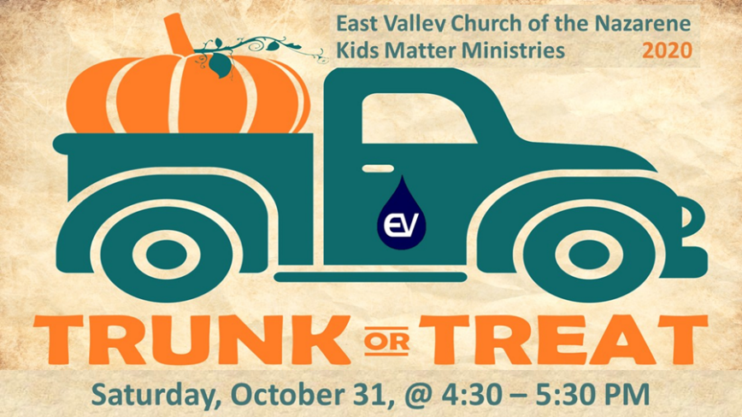
Come join the fun, decorate your vehicle, and pass out goodies to all the kids!

TRUNK OR TREAT
REGISTRATION FORM

Please Print:
NAME: ___________________________________________________________________
ADDRESS: _________________________________________________________________
CITY: __________________________________________ ZIP: _______________________
DAYTIME PHONE: ____________________ EMAIL ADDRESS: _______________________ VEHICLE: __________________________________________________________________
______ Yes, I would like to participate at the Annual Fall Festival / Trunk or Treat event.
Car/Truck Theme: __________________________________________________
______ Sorry, I am unable to participate, however, I will donate candy for the event.
______ Sorry, I am unable to participate or bring candy, but would love to help at the entrance.

Judging Criteria  Vehicles will be judged and creativity and adherence to the Bible Theme.  Entry Criteria  Please fill out this registration form completely and return by Wednesday, October 28, by emailing to pastorfrankie@evnaz.org or online registration at (link)  Or  Mail to: East Valley Church of the Nazarene  ATT: Pastor Frankie  PO BOX 51870  Mesa, AZ 85208 | Rules  - All entries must decorate with a BIBLE THEME.  - No gore-please keep decorations and costumes “kid-friendly”. BIBLE THEME  - No toy weapons-guns, knives, etc  - Adult Supervision required for all entries.  - All items must be age appropriate for children ages 2 to 12 years old.  - All items distributed must be individually wrapped.  - No homemade items may be given out.  - Cars must be turned off for the duration of the event

